
Auditor of Public Accounts

Local Government News and Updates
- The Fiscal Year 2026 Specifications for the Audits of Cities, Counties, and Towns (CCTs), and the Audits of Authorities, Boards, and Commissions (ABCs) have been published, as of June 25, 2026, located under Local Government Resources > Guidelines and Manuals.
Summary of Updates to the Fiscal Year 2026 Local Government Audit Specifications
- Various formatting and minor wording revisions and updates have been made throughout both the CCT and ABC Audit Specifications.
- Section 3-12, Children’s Service Act (CCT Audit Specifications) – applicable guidance has been updated to reflect changes from 2025 legislation (Senate Bill 801) related to eligibility criteria and use of state pool funds for target population. There have been no changes to existing audit procedures.
- Chapter 5 Treasurer’s Turnover Audits (CCT Audit Specifications) – several changes have been made throughout this chapter. These changes reflect the APA removing the requirement for CPA firms to conduct a Treasurer turnover audit as an examination engagement under AICPA attestation (SSAE) standards. The Audit Specifications now permit the CPA firm’s professional judgment to determine whether it performs the required turnover procedures in accordance with auditing/attestation standards.
- Chapter 6 Audits of Circuit Court Clerks (CCT Audit Specifications) – several updates have been made to guidance and audit procedures throughout this chapter to align with the audit procedures that our Office performs for audits of circuit court clerks.
- The APA local government team is currently working on updates to the various annual guidelines and resources for the fiscal year 2026 local government audits and reporting, with an expected completion date in early August. As applicable resources are continually updated they will be published at apa.virginia.gov > Local Government > Resources > Guidelines and Manuals.
- Final FY2026 Cardinal State Disbursement Report – the APA typically receives the final June year-end Cardinal data for the State Disbursement report during the last week of July. Please keep in mind that our Office’s receipt and review of the June data is dependent on the state’s timely completion of the final year-end close processes. Our office expects to publish the updated FY2026 Cardinal State Disbursement report with June year-end data as soon as practicable, with an estimated timeframe around July 31 to August 3.
- Code of Virginia requirements regarding a locality’s audit delay
- If a locality has not completed its fiscal year 2025 audit and has not submitted the required financial reporting to the Auditor of Public Accounts (APA), which was due by December 15, 2025, the locality is required to publish an audit delay notification on its website and notify the locality’s governing body and the APA concerning the delay.
- If your locality’s expected audit and financial report completion date changes, the Code of Virginia requires the locality to continue to update the audit delay notification until the audit is complete. Please be sure to also notify the APA with any update on the expected date for submitting the locality’s required fiscal year 2025 financial reporting to our Office.
Note: If your locality also remains delayed with submitting the FY2024 required financial reporting to our Office, please keep us updated with the expected completion date.
- The Reporting Requirements and Distribution Resource provides a summary of general reminders and key information for local government annual reporting submissions.
- The APA published the final version of the 2025 Comparative Report of Local Government Revenues and Expenditures on April 26, 2026.
- As of the April 26 publication date, 32 localities did not submit their fiscal year 2025 transmittal data and audited financial reports in time for inclusion in the final report. Our Office will publish an amended version of the 2025 Comparative Report to include data for missing localities after we receive the required financial reporting information.
- Refer to summary information below at pp. 3-5 of this document for guidance on navigating and accessing various information, data, and resources published on the APA’s updated Local Government website page.

Summary For Navigating the APA Local Government Page
https://www.apa.virginia.gov/local-government

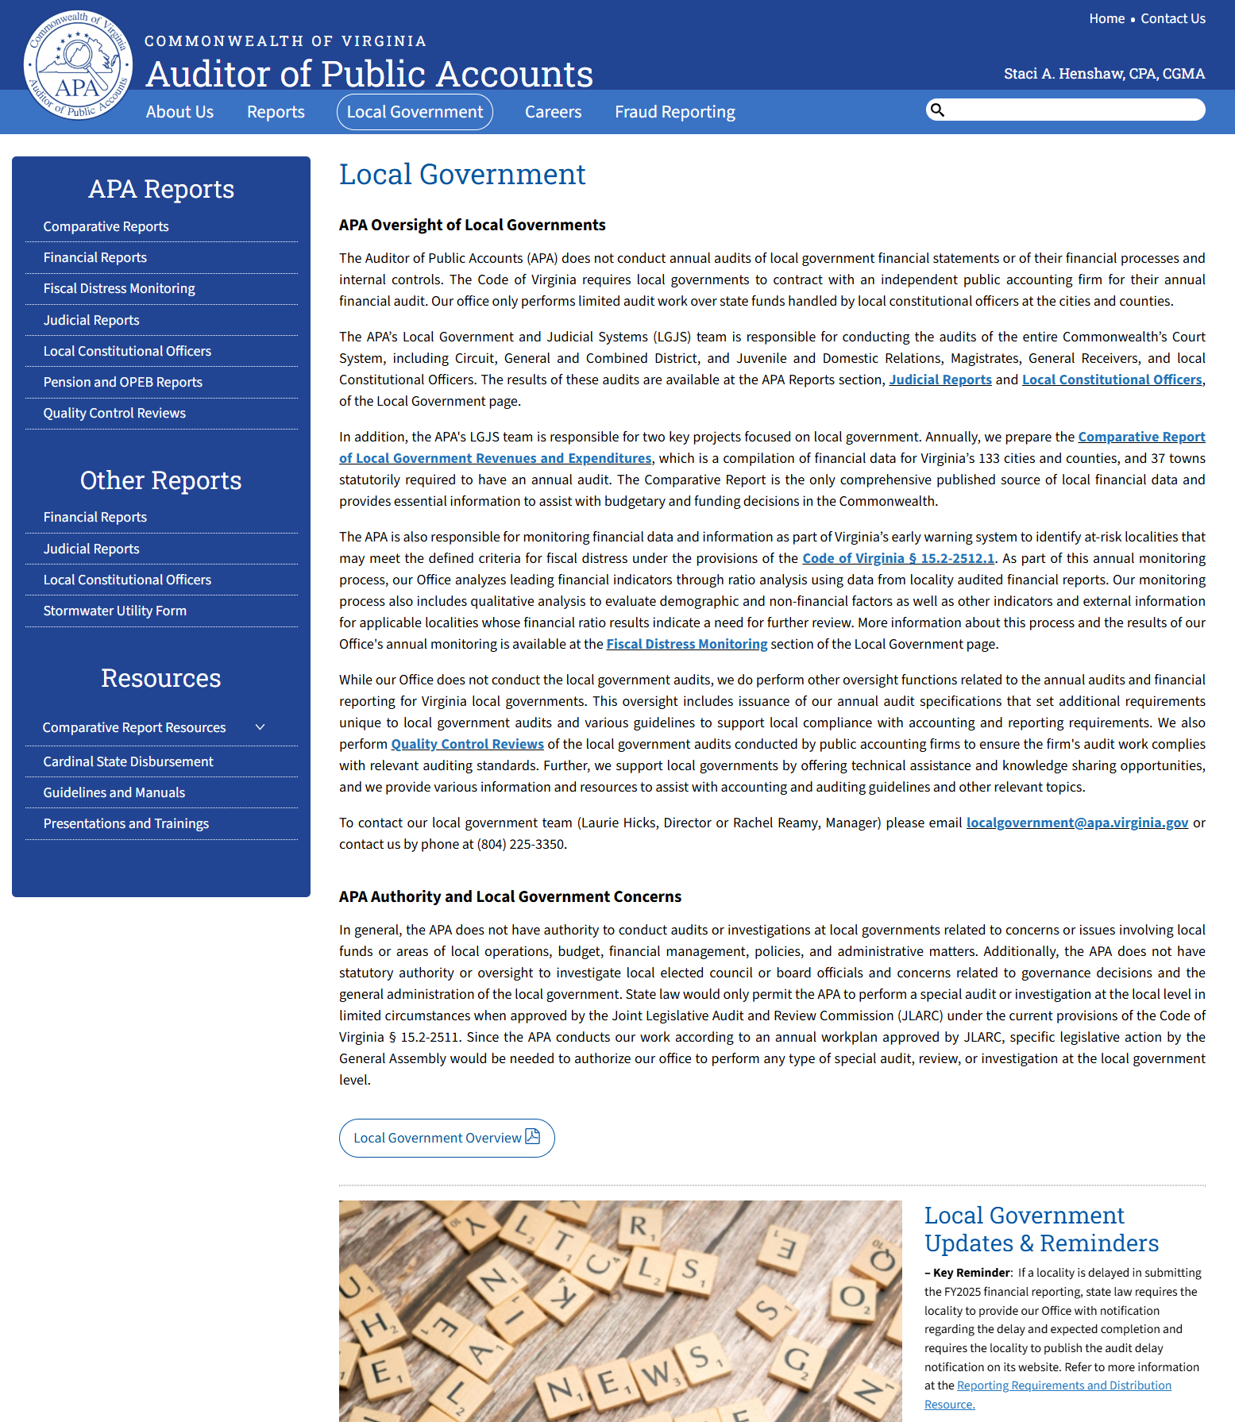

During February 2024, the APA launched a new website platform. As such, all URL hyperlinks to local government resources have changed. Please note that the URL hyperlinks for all local government reports and resources published on the APA website no longer contain apa.virginia.gov in the URL domain. The URL domain name now points to the Commonwealth agency Division of Legislative Automated Systems’ (DLAS) data content and cloud-based web-hosting platforms (via Directus and Microsoft Azure), as DLAS is assisting our office with managing the APA website.

For example, the URL hyperlink for the Uniform Financial Reporting Manual resource is now:
https://dlas-directus-prod.azurewebsites.net/assets/3A9D01DC-8718-4053-9D3D-BD57BA48081A.docx

Note: If you are unable to see updated information/data in the various resource files when downloading from our website (e.g.: guidance documents, manuals, Cardinal reports), you may need to first clear your browser cache to remove prior versions of the files, then download the updated file again.
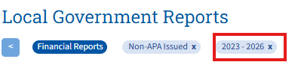
Important: Please note when you access local government information from the Reports or Resources sections an automatic Year filter ‘2023-2026’ is applied to the search criteria, as this helps ensure a faster load time for the website. You may need to first close this filter to find an applicable report or to see all available resources. You can do so by clicking the x next to the Year filter criteria. See example screen shot of this to the right.

Local Government Reports

Local Government-related reports are organized into two main categories: reports issued by our office (located in the APA Reports section) and those issued by external CPA firms (located in the Other Reports section).

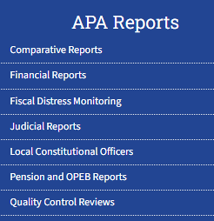
The APA Reports section includes internally issued reports for local related audits, special projects, quality control reviews over CPA firms performing local government audits, and other areas. The Judicial Reports section now includes all APA issued reports for court/judicial audits, constitutional officer turnovers, and the results of audits over state funds held by constitutional officers.

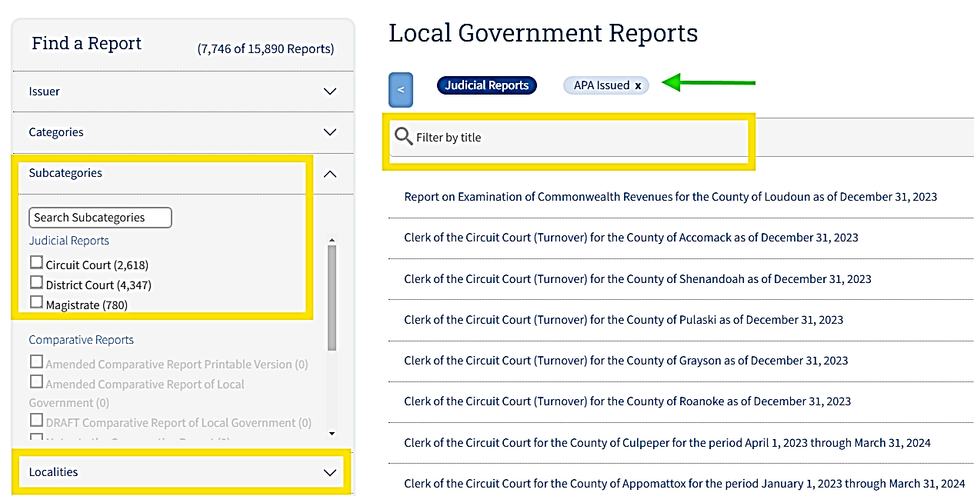
Once navigating to one of the APA Reports category options, you can search on various report types under the Find a Report feature, and filtering by the ‘Subcategories’ menu. You can also search for a specific locality report by filtering the ‘Localities’ menu or using the Filter by Title search feature at the top of the reports listing.

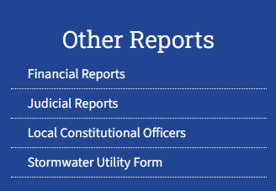
The Other Reports section includes financial related reports issued by external CPA firms for localities (cities, counties, and towns), along with other governmental entities that have submitted their annual audit reports to our office such as local authorities, boards, commissions, districts, and small towns that elect to have an audit. This section also includes reports for the judicial audits over certain Clerks of the Circuit Court and other audits over constitutional officers performed by an external CPA firm.

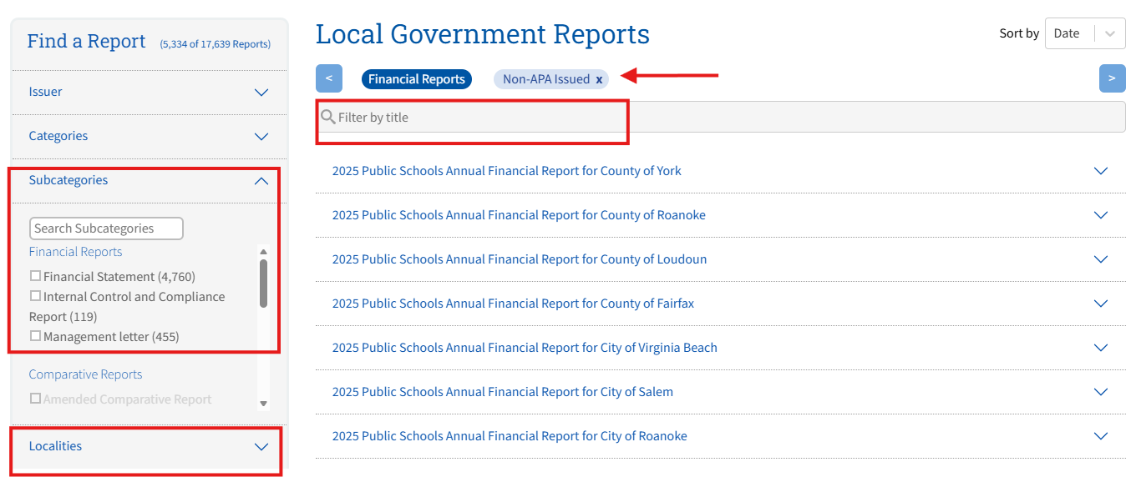
Once navigating to one of the Other Reports category options, you can search on various report types under the Find a Report feature, and filtering by the ‘Subcategories’ menu. You can also search for a specific locality report by filtering the ‘Localities’ menu or using the Filter by Title search feature at the top of the reports listing.

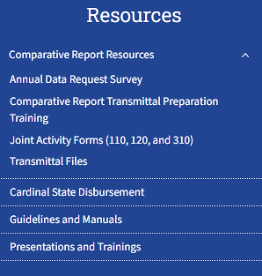
The Resources section of the Local Government website page includes important guidelines, manuals, and other helpful guidance, such as the Cardinal State Disbursement reports, the annual Audit Specifications, Uniform Financial Reporting Manual, and many other documents published and updated annually. This section also contains all files related to the Comparative Report Transmittal process, such as Transmittal preparation and training resources, the locality specific annual surveys, and the locality specific Transmittal workbooks.

All relevant guidelines, manuals, and other guidance documents are available by selecting the Guidelines and Manuals category option. You can search for the various types of resources under the Find a Report feature, and filtering by the ‘Subcategories’ menu. You can also search for a specific resource by typing a keyword in the Filter by Title search feature at the top of the documents listing.
